BRAZILIAN E-COMMERCE MARKETPLACE SALES
ANALYSIS

1. Project Overview and Objective
This project involves cleaning, transforming, and analysing Brazilian e-commerce marketplace data using Excel and developing an interactive Power BI dashboard to visualize sales performance and derive meaningful business insights. The project includes data preprocessing, VLOOKUP-based data integration, calculated fields, Pivot Table analysis, Power BI data modeling, DAX measures, and interactive visualizations based on product category, time, payment type, and geographical location.

The main objective of this project is to demonstrate data preprocessing, cleaning, transformation, and analysis techniques using Excel, followed by the development of an interactive Power BI dashboard to visualize Brazilian e-commerce sales data and derive meaningful business insights.
2. Data Sources
● Source Description and Timeline: Olist Brazilian E-Commerce Marketplace Dataset / Kaggle and 2016–2018.
● Domain: E-Commerce / Retail / and Sales Analytics .
3. Problem Statement
● To analyse e-commerce sales performance across product categories, months, payment types, and geographical locations.
● To identify sales trends and understand the performance of different product categories and regions.
● To analyse customer orders, payment preferences, and average order value for better business decision-making.
● To understand delivery-related factors such as delivery time, shipping cost, and product load for improved e-commerce analysis.

4. Attribute (Column /Features) Details:
Attribute Name | Data Type | Description
ORDER_ID | String (Text) | Unique identifier for each order
CUSTOMER_ID | String (Text) | Unique identifier for each customer
PRODUCT_ID | String (Text) | Unique identifier for each product
SELLER_ID | String (Text) | Unique identifier for each seller
ORDER_STATUS | Categorical | Current status of the order
ORDER_PURCHASE_TIMESTAMP | Date/Time | Date and time when the order was placed
PRICE | Numeric (Decimal) | Price of the ordered product
FREIGHT_VALUE | Numeric (Decimal) | Shipping or freight cost of the product
PAYMENT_TYPE | Categorical | Payment method used for the order
PRODUCT_CATEGORY_NAME | Categorical | Category of the product
CUSTOMER_ZIP_CODE_PREFIX | Numeric | Customer location ZIP code prefix
CUSTOMER_CITY | Categorical | City of the customer
CUSTOMER_STATE | Categorical | State of the customer
PRODUCT_WEIGHT_G | Numeric (Integer) | Weight of the product in grams
PRODUCT_LOAD | Categorical | Product load category based on product weight
FINAL_PRICE | Numeric (Decimal) | Product price including shipping cost
TIME_DELIVERY | Numeric (Integer) | Time taken to deliver the order

5. Tools & Technologies
● Excel: Data cleaning, transformation, VLOOKUP, calculated fields, Pivot Tables, and Pivot Charts.
● Power BI: Data modelling, DAX calculations, data visualization, and interactive dashboard creation
6. Data Pre-Processing (Excel / Power Query)
Tasks Performed:
● Data Cleaning & Transformation: Removed duplicate records, handled missing and inconsistent values, standardized data formats, removed irrelevant columns, and created calculated fields such as Final Price, Delivery Time, Product Weight, and Product Load.
● Data Integration: Used VLOOKUP to combine information from different datasets, including customer, product, payment, location, and order details.
● Filtering & Sorting: Sorted and filtered the data based on relevant fields such as Product Load and Shipping Limit Date for analysis.
● Pivot Tables: Created Pivot Tables and Pivot Charts to summarise sales by product category, state, payment method, delivery charges, and product load.
● Fact and Dimension Tables: Prepared separate analytical tables such as Sales Details, Products Details, Customers Location, Sellers Location, Orders Delivery, Order Payments, Order Reviews, and Geography for Power BI data modelling.

7. Data Modelling and DAX (Power BI)
● Data Model: Established relationships between the tables, defined appropriate cardinality, and connected tables such as Customers Location, Sellers Location, Products Details, Sales Details, Orders Delivery, Order Payments, Order Reviews, and Geography.
SCREENSHOT OF DATA MODELLING
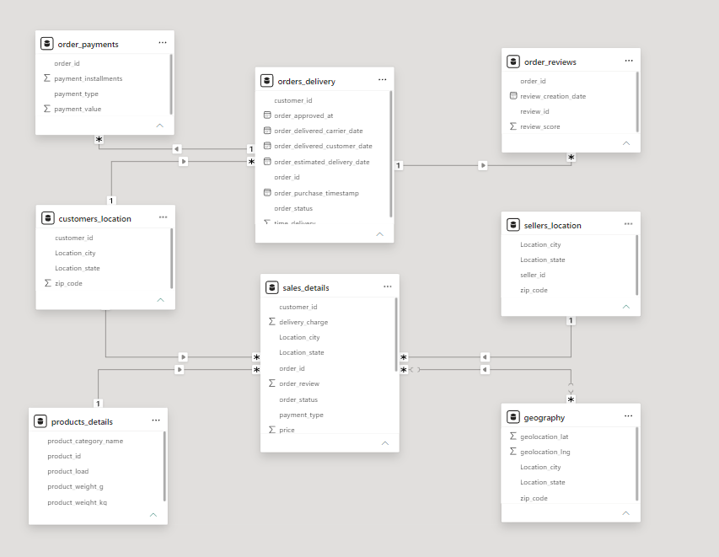
● Calculated Columns & DAX Measures: Created DAX measures for the key metrics used in the Power BI dashboard. The project document specifically includes the following:
- Total Sales – Calculates the overall sales amount.
- Total Orders – Calculates the total number of orders.
- Total Customers – Calculates the total number of customers.
- Average Order Value – Calculates the average value of an order.
DAX Measures:
Total Sales = SUM(Sales_Details[Final_Price])

Total Orders = DISTINCTCOUNT(Sales_Details[Order_ID])

Total Customers = DISTINCTCOUNT(Sales_Details[Customer_ID])

Average Order Value = DIVIDE([Total Sales], [Total Orders])
These measures are used in the Power BI Card visuals to present the main business KPIs.

8. Analysis and Visualizations (Power BI)
Dashboard Features:
● Multiple Visualizations: Created different visualizations to analyse and communicate e-commerce sales insights, including:
● Bar Chart – Sales by Product Category
● Bar Chart – Sales by Month
● Column Chart – Yearly Sales Trend
● Donut Chart – Sales by Payment Type
● Bar Chart – Sales by Payment Type
● Map – Sales by Geographical Location
● Cards – Total Sales, Total Orders, Total Customers and Average Order Value.
● Interactive Layout: Used filters, slicers and drill-down features to allow users to explore the report and analyse the data from different perspectives.
● Bookmarks: Used bookmarks to provide an interactive and user-friendly navigation experience between report views.
● Clear Titles and Labels: Added appropriate titles, data labels, legends and headings to make each visualization easy to understand.
● Consolidated Report / Dashboard: Combined KPI cards, charts and geographical visualizations into a single interactive Brazilian E-Commerce Marketplace Sales Analysis report.
SCREENSHOT OF REPORT
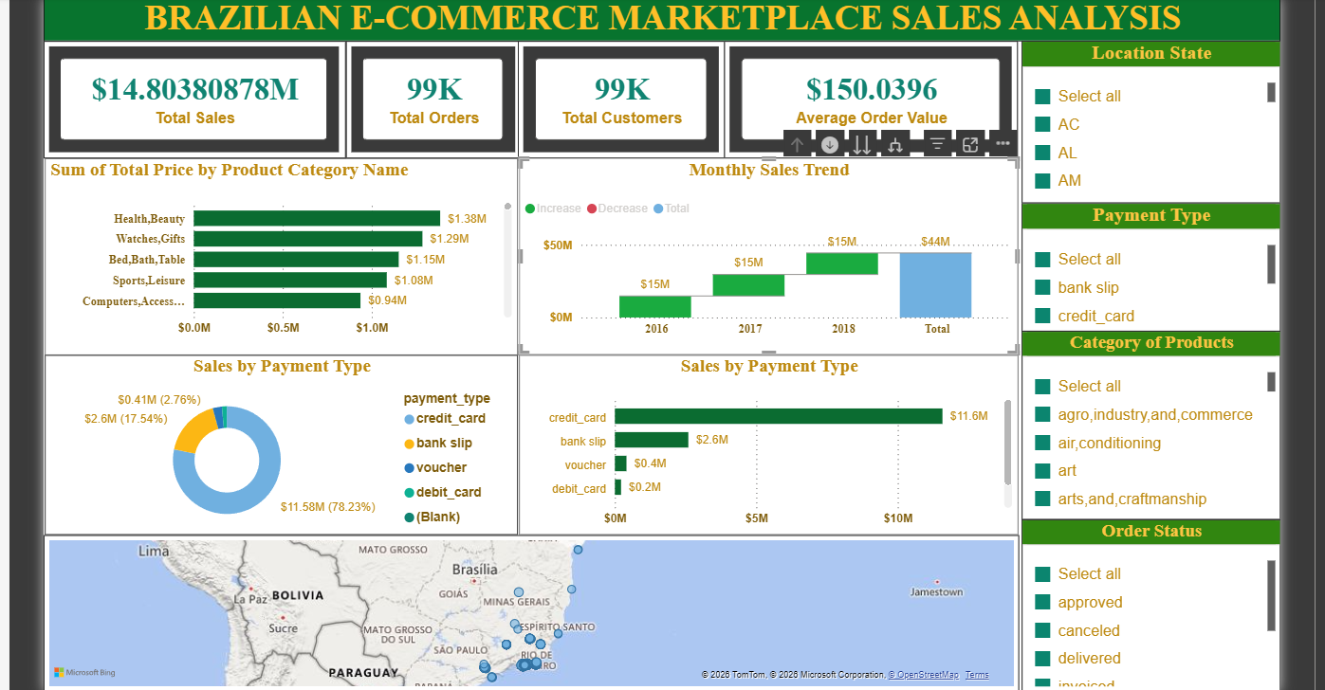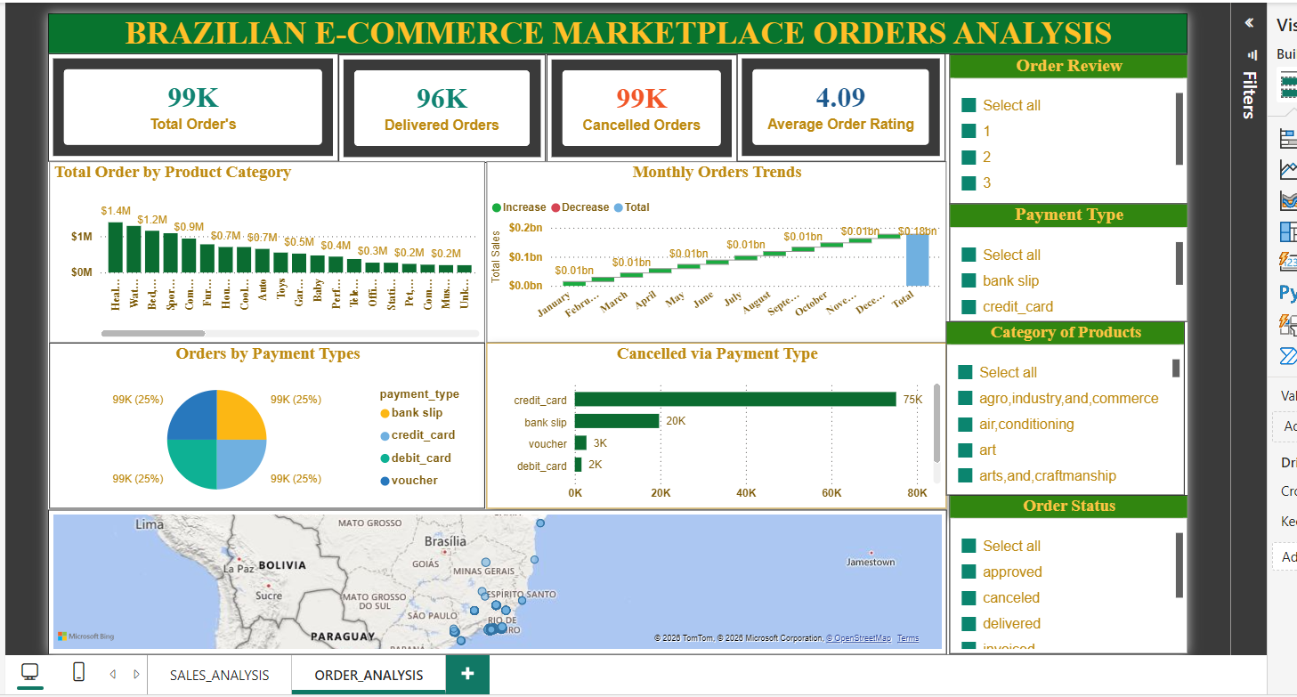

9. Insights & Conclusions

● Descriptive Analysis
- Analysed sales by product category, payment type, month, year, and location.
- Summarised total sales, orders, customers, and average order value.

● Diagnostic Analysis
- Compared sales performance across product categories and geographical locations.
- Examined payment preferences and sales trends to understand performance differences.

● Predictive Analysis
- No predictive model or forecasting technique was implemented in this project.

● Prescriptive Analysis
- The analysis can support decisions related to product performance, payment preferences, and geographical sales.

10. Conclusions
The integration of Excel and Power BI proved effective for end-to-end analysis of Brazilian e-commerce data, from data cleaning and transformation to data modelling and interactive visual reporting. The project helped identify sales patterns across products, payment types, time periods, and geographical locations, supporting better business decision-making.

